**Table of Content**

|  |  |  |
| --- | --- | --- |
| **S.No** | **Topic** | **Page.No** |
| 1. | Introduction | 1 |
| 2 | Database Design | 2 |
| 3 | Entity Relationship Diagram | 3 |
| 4 | Database Structure | 5 |
| 5 | Database Tables | 6 |
| 6 | Tables Queries | 11 |
| 7 | Stored Procedures | 14 |
| 8 | Data Population | 16 |
| 9 | Analysis and Visualizations | 20 |
| 10 | Power Bi Dashboard | 28 |
| 11 | Conclusion | 29 |
| 12 | References | 30 |

**INTRODUCTION**

LSBU Property Developers Ltd. is a company specializing in buying, renovating, and reselling properties in and around the London area. Their business model revolves around purchasing properties from licensed auctions, renovating them to increase their value, and then selling them for a profit. LSBU focuses on various types of properties, including houses, bungalows, flats, and maisonettes.

The company operates with a small team of four Property Scouts who attend property auctions to purchase suitable properties for renovation. Each purchased property undergoes a thorough inspection, and a list of required repairs is compiled by an LSBU surveyor. LSBU has a list of standard repairs, each with estimated costs and time constraints, which helps in assessing the overall renovation needs and estimating the associated expenses.

LSBU collaborates with skilled workers for performing specific repairs on the properties. They have a policy of assigning only one skilled worker to each repair task to ensure proper monitoring and assessment of the repair quality, budget, and timelines. The resale value of each property is calculated by adding the repair costs and a commission percentage to ensure a reasonable profit margin upon sale.

Once all repairs are completed, each property undergoes a final inspection by an LSBU surveyor. If the work meets the required standards, a completion certificate is issued for the property. LSBU has gained a reputation for providing regular work opportunities for skilled local workers in the building trade.

LSBU advertises renovated properties for sale on their website, where interested buyers can view property details and make purchase inquiries. When a buyer expresses interest in purchasing an LSBU property, a sale contract is drawn up between the buyer and LSBU. The buyer is required to provide a deposit upon signing the contract, with the remaining balance due within 28 days.

LSBU is looking to improve its business operations by implementing a new computer-based system. As part of this effort, they seek advice from business consultants to optimize their processes and develop a prototype database system to support their operations effectively. This report aims to model LSBU's existing business processes, propose improvements, and outline changes for implementing a new database system to enhance efficiency and productivity.

**DATABASE DESIGN**

Database design is the process of organizing data according to a database model. It involves determining what data is to be stored and how the data elements relate to each other. The primary purpose of database design is to create physical and logical models of the proposed database system.

**Objectives of Database Design**

The primary objectives of this database design are:

* Data Integrity: Ensure data accuracy and consistency by enforcing data validation rules and minimizing redundancy.
* Data Accessibility: Facilitate easy retrieval of information through well-defined tables, relationships, and efficient querying capabilities.
* Scalability: Design a database structure that can accommodate future growth in data volume and complexity.
* Security: Implement robust security measures to protect sensitive information from unauthorized access and modification.
* Performance: Optimize the database for efficient data retrieval and manipulation to support timely information access.

**ENTITY-RELATIONSHIP DIAGRAM (ERD)**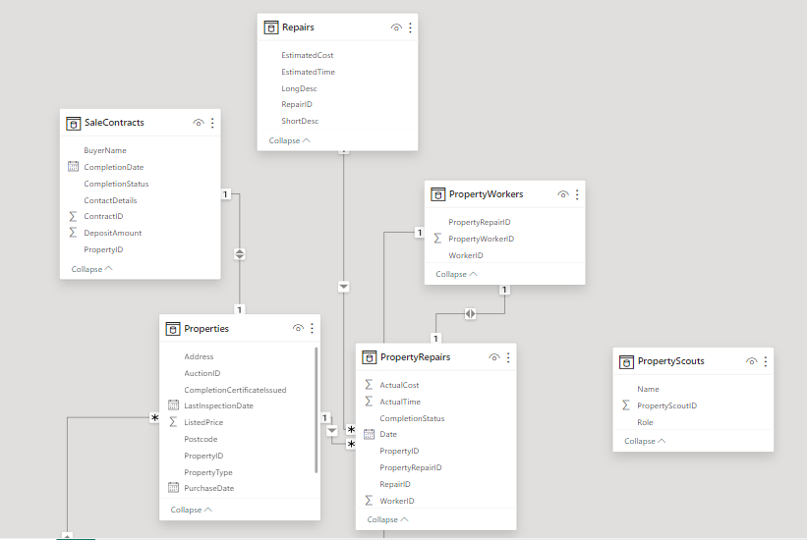

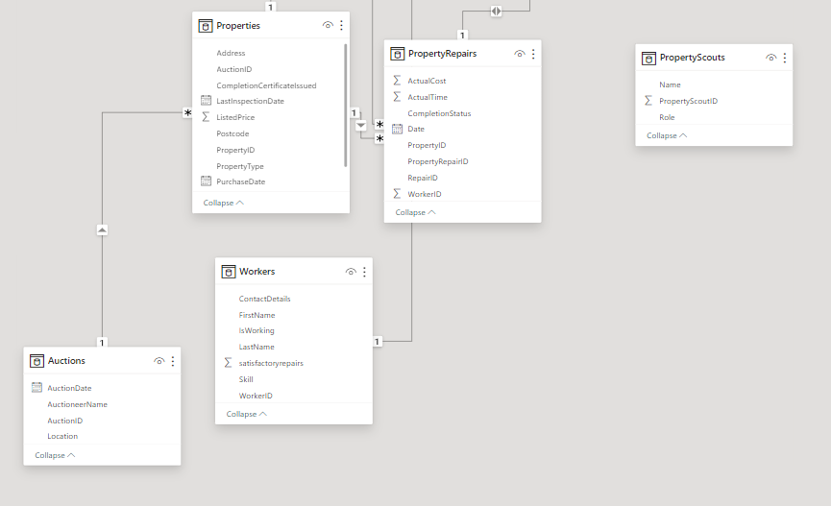

**LSBU'S DATABASE STRUCTURE AND KEY INFORMATION INTEGRATION**

LSBU Property Developers Ltd engages in a property renovation business, acquiring properties from auctions, renovating them, and then selling them for a profit. LSBU is a company that buys and improves properties. They mainly get properties from auctions where they think they can make a good investment. To find these properties, they send scouts to different auctions. They check each property carefully and make a list of what repairs are needed. They have a list of common repairs and how much they usually cost.

LSBU works closely with skilled workers, assigning one worker to each repair job to make sure it's done well and on time. After fixing up the properties, they put them up for sale on their website.

They keep detailed records of everything related to their properties, like what they bought, what repairs were done, and all the sales. This helps them make smart decisions and build good relationships with everyone involved.

**Database Schema**

The database creation process for LSBU Property Developers Ltd. was a comprehensive endeavor aimed at designing a robust system to manage property-related information. Tables were carefully crafted to capture essential details ranging from property specifications to repair records, worker information, and sales contracts. Establishing relationships between tables using foreign key constraints ensured the integrity of the data stored within the database. Throughout the development process, the database schema underwent iterative refinement to align with project requirements and accommodate feedback from stakeholders. Rigorous testing procedures were implemented to verify that the database effectively facilitated tasks related to property acquisitions, renovations, and sales, meeting LSBU's operational needs.

**DATABASE TABLES**

**Auctions**

* Stores auction details like ID, date, location.
* Contains categorical and temporal auction data.

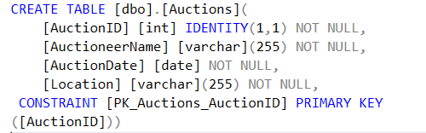

**Properties**

* Holds property information such as type, address, price.
* Central repository for property-related data.

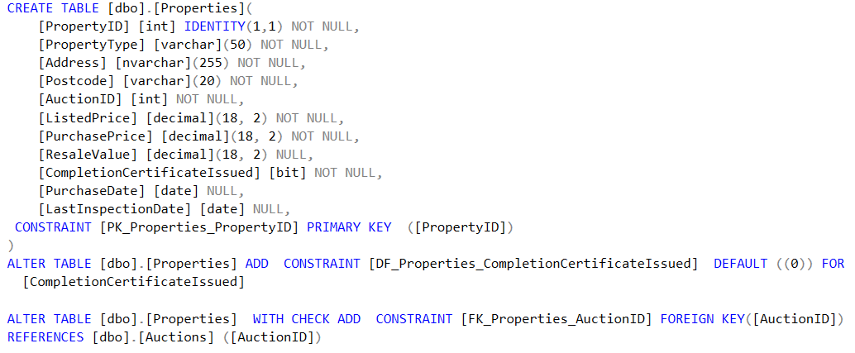

**PropertyRepairs**

* Tracks property repair details like cost, time, status.
* Facilitates efficient property maintenance.

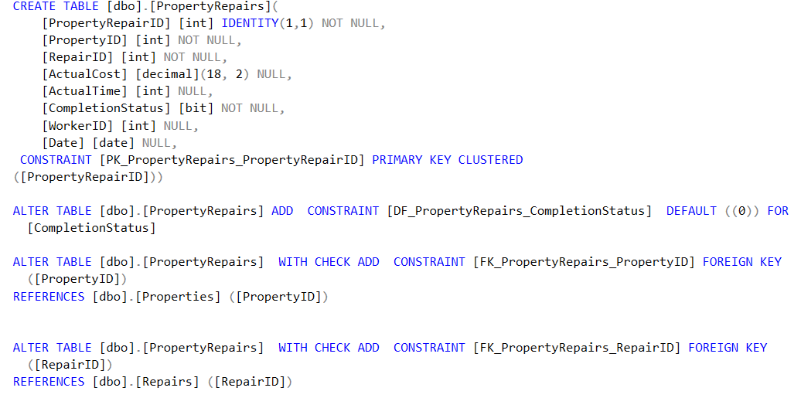

**PropertyScouts**

* Records LSBU's scouting team details.
* Helps assess scout contributions to property acquisition.

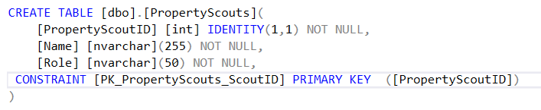

**PropertyWorkers**

* Manages skilled workers involved in property repairs.
* Facilitates assignment and monitoring of repair tasks.

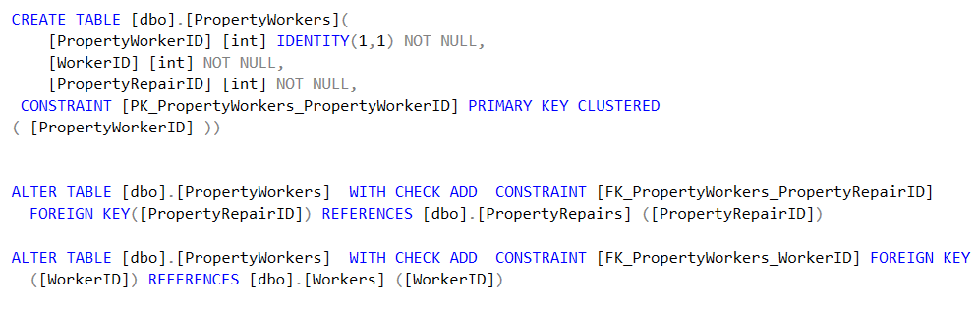

**Repairs**

* Contains repair task details and estimates.
* Assists in planning and budgeting repair activities.

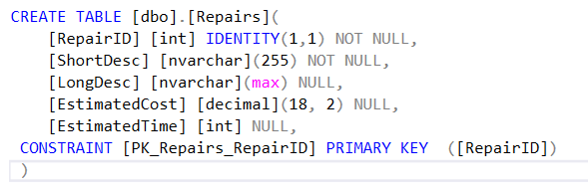

**SaleContracts**

* Stores sale contract information for properties.
* Facilitates management of property sales transactions.

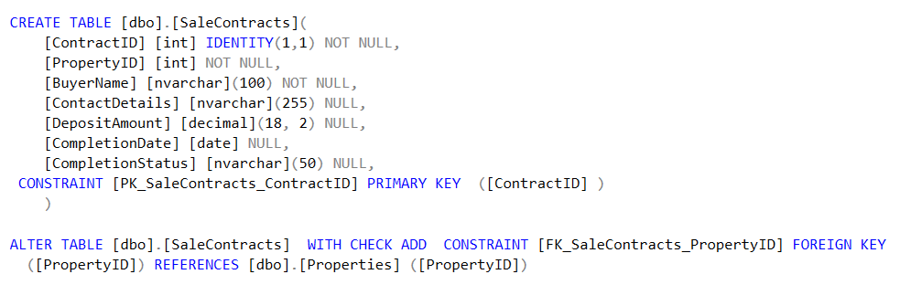

**Workers**

* Maintains information about skilled workers.
* Helps manage workforce and assign repair tasks.

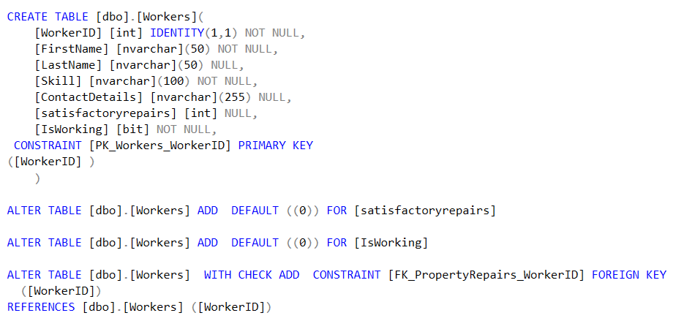

**Relationships**

* Property to Auction: Many-to-One (Each property is associated with one auction, but an auction can have multiple properties)
* Property to Repair: One-to-Many (Each property can have multiple repairs)
* Repair to Worker: Many-to-One (Each repair is assigned to one worker, but a worker can perform multiple repairs)x
* Property to SaleContract: One-to-One (Each property has one sale contract)

**Set-up and test queries using SQL**

1. Write a query to find which skilled worker carried out the highest number of satisfactory repairs last month?

**Query**

This query selects the top worker who carried out the highest number of satisfactory repairs last month. It joins the Workers and PropertyRepairs tables to retrieve the necessary information.

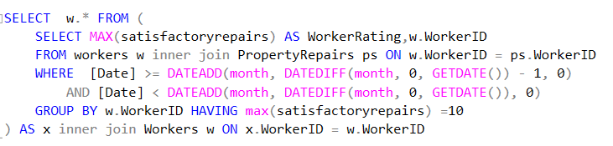

**Output**

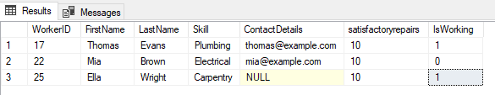

1. Write a query to find how many properties were purchased by LSBU during the period Oct 2022 – Dec 2023?

**Query**

This query selects the count of properties from the Properties table where the PurchaseDate falls within the specified period.

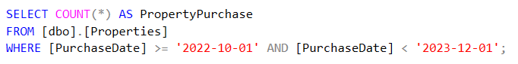

**Output**

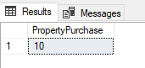

OR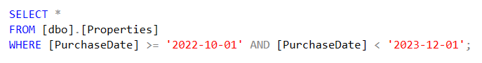

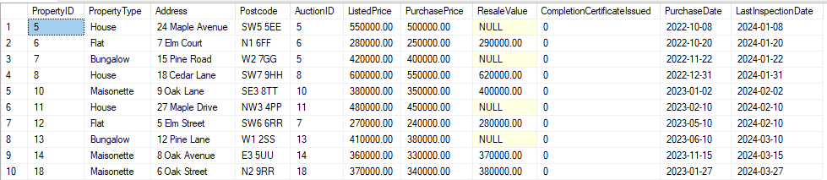

1. Write a query to find out how many skilled workers are available (not currently working on any LSBU renovation) today?

**Query**

This query checks the Workers table for those marked as available and then uses a NOT EXISTS subquery to filter out workers who are currently assigned to any renovation project for LSBU based on the PropertyWorkers and PropertyRepairs tables. Finally, it counts the number of available workers matching above criteria.

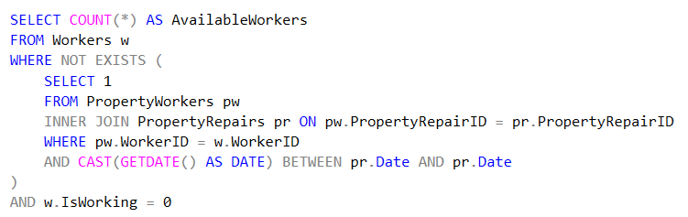

**Output**

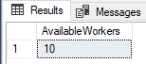

**STORED PROCEDURES**

* The **GetCompletedSalesLastMonth** stored procedure retrieves data on completed property sales from the previous month. It offers insights into the number of properties successfully sold within a specific timeframe, aiding in performance analysis and decision-making. This procedure assists LSBU in monitoring sales trends and evaluating the effectiveness of their marketing and sales strategies.

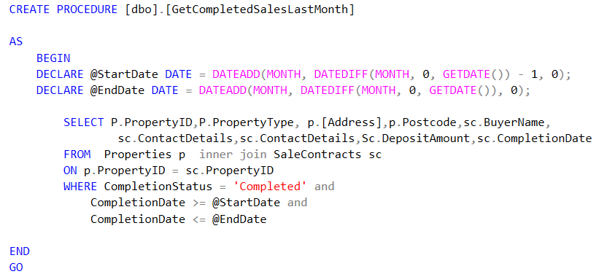

**Code Explaination**

* The "GetCompletedSalesLastMonth" stored procedure retrieves details of completed property sales from the previous month. It sets start and end dates for the previous month. Then, it selects property ID, type, address, postcode, buyer name, contact details, deposit amount, and completion date from the "Properties" and "SaleContracts" tables. The procedure filters records based on completion status, ensuring only completed sales are included, and limits the results to sales within the previous month.

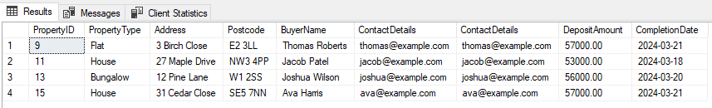

* The **MonthlyReinspectionReport** stored procedure generates a report detailing properties requiring re-inspection by LSBU surveyors. It lists repair costs for each property, aiding in cost analysis and budgeting. This procedure helps LSBU ensure that properties meet quality standards before being put up for sale, enhancing customer satisfaction and reputation.

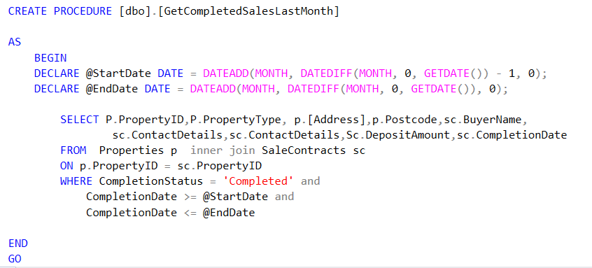

**Code Explaination**

* The "**MonthlyReinspectionReport**" stored procedure It lists property details like ID, type, address, purchase price, last inspection date, and resale value. Additionally, it calculates total repair cost and number of repair times for each property. The procedure filters properties based on last inspection date, retrieves relevant data from "Properties" and "PropertyRepairs" tables, and orders the report by property ID.

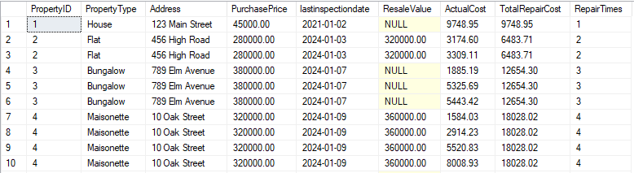

**DATA POPULATION**

The database was populated with sample data using SQL INSERT statements executed against each respective table. These INSERT statements were carefully crafted to ensure that the sample data accurately reflects the real-world scenarios and requirements of LSBU's property management system.

**Auctions Data:**

The auctions data includes information about various property auctions, such as the auctioneer's name, auction date, and location. This data allows us to track the properties purchased by LSBU over time and analyze their acquisition patterns.

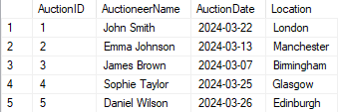

**Properties Data:**

The properties data contains details about the properties purchased by LSBU, including property type, address, postcode, listed price, purchase price, and inspection date. This data enables us to analyze the types of properties acquired, their prices, and the frequency of inspections.

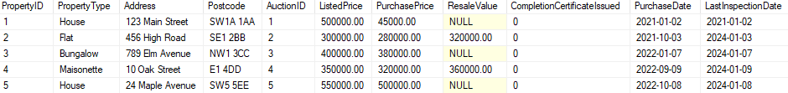

**Property Scouts Data:**

Property scouts are integral to LSBU's acquisition process, and their information, including their names and roles, helps us understand the individuals involved in sourcing properties for renovation.

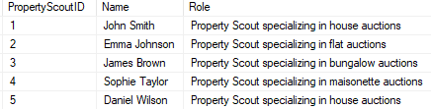

**Repairs Data:**

The repairs data lists various repair tasks along with their descriptions, estimated costs, and estimated time for completion. This data allows us o analyze the repair needs of LSBU's properties and estimate the overall renovation costs.

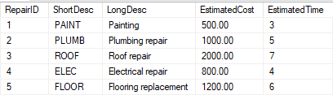

**Property Repairs Data:**

Property repairs data tracks the repairs carried out on each property, including the actual costs, actual time taken, and completion status. This data enables us to assess the efficiency of repair operations and track the progress of property renovations.

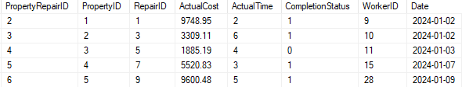

**Workers Data:**

The workers data contains information about skilled workers available for repair tasks, including their names, skills, and contact details. This data helps us manage the workforce and assign repair tasks to suitable workers.

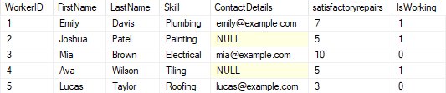

**Property Workers Data:**

Property workers data establishes relationships between properties and workers assigned to perform repairs. This data allows us to track which workers are working on specific properties and monitor their performance.

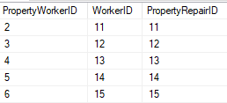

**Sale Contracts Data:**

Sale contracts data captures details of property sales contracts, including property IDs, buyer names, contact details, deposit amounts, completion dates, and completion statuses. This data enables us to analyze property sales transactions and track the revenue generated from property sales.

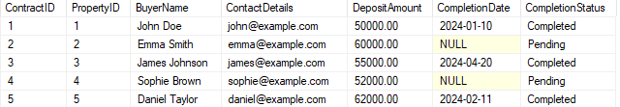

**Data Testing**

All sample data added to the database has been thoroughly tested to ensure its accuracy, consistency, and integrity. Various SQL queries and operations have been performed on the database to validate the functionality of data retrieval, insertion, updating, and deletion. Additionally, data validation checks and constraints have been enforced to maintain data quality and prevent any inconsistencies. Overall, the sample data has undergone rigorous testing to verify its suitability for analysis and decision-making processes within LSBU's property management system.

**ANALYSIS AND VISUALIZATIONS**

**1.** Total Number of Properties Purchased at Auctions Over Time:

The line chart below illustrates the trend of properties purchased at auctions with in last month . It shows the fluctuation in the number of properties acquired by LSBU across different auction dates.

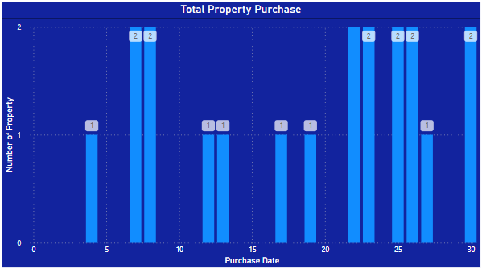

**2.** Total Number of Repairs Completed by Each Worker:

The bar chart displays the total number of repairs completed by each worker. It provides insights into the productivity and contribution of individual workers towards property renovations.

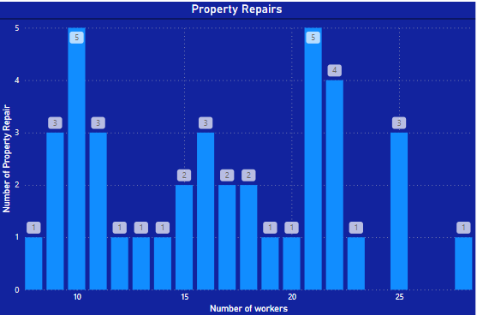

**3.** Average Deposit Amount Received:

The card visualization showcases the average deposit amount received for property sales contracts. It highlights the average financial commitment made by buyers during property transactions.

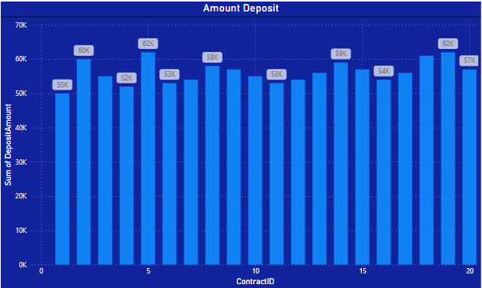

**4.** Distribution of Property Types:

The pie chart represents the distribution of property types purchased by LSBU. It illustrates the proportion of different property types in LSBU's portfolio, such as houses, bungalows, flats, and maisonettes.

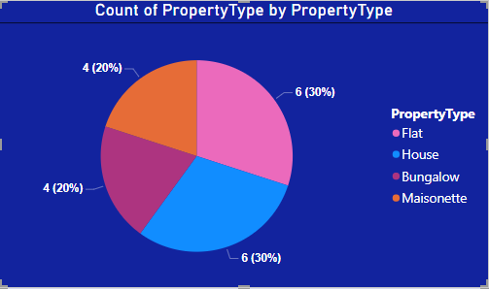

**5.** Property Resale value

This visualization offers a concise overview of property resale values categorized by property ID, aiding LSBU Property Developers Ltd. in understanding the value distribution across their portfolio for effective decision-making.

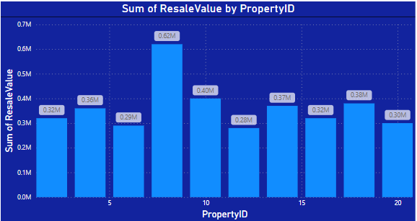

**6.** Comparison of Listed Price and Purchase Price:

The scatter plot compares the listed price and purchase price of properties acquired by LSBU. It helps identify any discrepancies between the listed prices set at auctions and the actual purchase prices paid by LSBU.

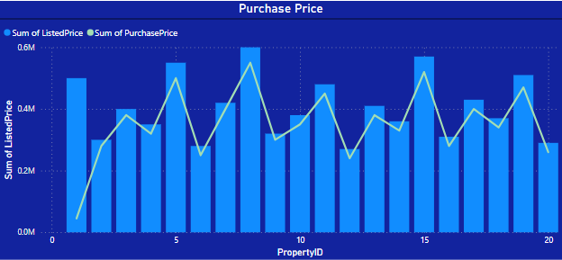

**Insights and Observations**

Trend Analysis: The line chart reveals fluctuations in property acquisitions over time, indicating LSBU's buying patterns and market activity.

Worker Productivity: The bar chart highlights variations in repair completion rates among workers, enabling LSBU to identify top-performing workers and allocate resources efficiently.

Financial Metrics: The average deposit amount visualization provides insights into buyer commitment levels during property transactions, informing LSBU's financial planning and revenue projections.

Property Portfolio Composition: The pie chart illustrates the composition of LSBU's property portfolio by type, guiding strategic decisions regarding property acquisitions and diversification.

Repair Progress: The chart offers a snapshot of repair completion status, aiding LSBU in tracking repair progress and addressing any delays or bottlenecks in the renovation process.

Overall, these visualizations provide valuable insights into LSBU's property management operations, facilitating data-driven decision-making and performance evaluation.

**Data Visualization**

The data visualizations in Power BI offer a clear and concise representation of key metrics and trends within LSBU's property management operations.

Each chart and graph provides a visual summary of complex data, making it easier to interpret and derive insights at a glance.

By using various visualization types such as bar charts, line charts, and pie charts, we were able to present data from different perspectives, allowing for a comprehensive analysis of LSBU's property portfolio.

The visualizations not only enhance understanding but also aid in decision-making by highlighting areas of opportunity, identifying potential risks, and showcasing performance metrics against predefined targets.

**Key Insights from Power BI Visualizations**

* Count of workers engaged in property repairs.
* Aggregated deposit amounts per property sale.
* Total properties acquired in the previous month.
* Quantity of property repairs conducted by workers.
* Breakdown of property purchases by type, including houses, apartments, flats, and bungalows.

**POWER BI DASHBOARD INSIGHTS**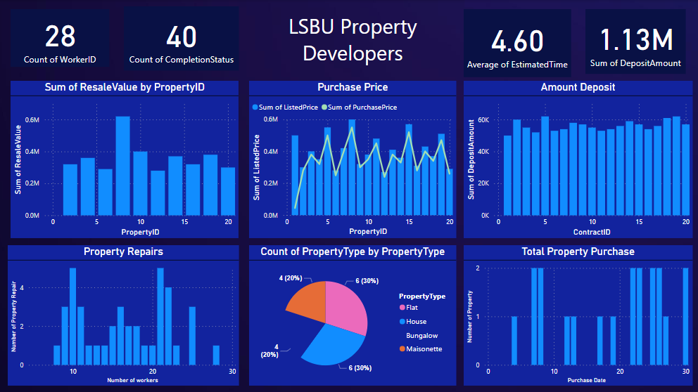

**CONCLUSION**

In conclusion, the development of the database system for LSBU Property Developers Ltd. marks a significant step towards streamlining their property management operations. By meticulously designing and implementing the database, LSBU now has a robust platform to track property acquisitions, manage repairs efficiently, and make informed financial decisions. Through thorough analysis, key insights have been uncovered, enabling LSBU to optimize its property portfolio, enhance operational efficiency, and maximize profitability.

Moving forward, the database system will continue to serve as a cornerstone of LSBU's property management strategy, facilitating data-driven decision-making and fostering continuous improvement. By leveraging the insights gleaned from the database, LSBU can adapt to market dynamics, identify new opportunities, and stay ahead in the competitive real estate landscape. With a strong foundation in place, LSBU is well-positioned to achieve its business objectives and drive sustained growth in the property development sector.

**REFERENCES**

These resources have been instrumental in guiding the development and analysis of the database system, ensuring its alignment with LSBU's business objectives and requirements.

* LSBU Property Developers Ltd. Business Requirements Document

Utilize Google as a valuable tool for accessing a wide range of database-related information and references

* Database Design and Implementation Guidelines

<https://www.geeksforgeeks.org/database-design-in-dbms/>ss

* SQL Server Documentation

<https://learn.microsoft.com/en-us/sql/t-sql/language-reference?view=sql-server-ver16>

* Power BI Documentation

<https://learn.microsoft.com/en-us/power-bi/fundamentals/desktop-getting-started>

* Data Visualization Best Practices

<https://learn.microsoft.com/en-us/power-bi/visuals/power-bi-report-add-visualizations-i?tabs=powerbi-desktop>